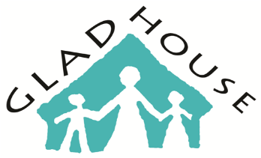
GLAD House Referral Form
Date: | Referral Source:
Person Referring: | Relationship to client:
Phone # : | Email:
Name and Relationship of Legal Guardian:

Guardian number and email :
Guardian Ad Litem name, number, and email:

Potential Client’s address:

Child’s Name | DOB | AGE | Gender | Hamilton County Resident Y/N | Medicaid  #  (if available) | SSN (if available) | MH  Diagnosis  (if available)

Client’s School: | Grade: | Dismissal Time:
Presenting Problem:

Has client/family been impacted by addiction? – How & Drug of Choice History:

Is the Child Receiving Therapy or Other Services Elsewhere: Y/N

If yes what services do they receive?

Can child function in a group setting? Y / N Does child have an active IEP/ 504 Plan? Y / N
Does child have any history of acting out sexually? Y / N
Does child/youth have any history of using substances? Y / N
Please fax completed referral form to Kendra Browning at 513-482-7042
Office Screening Prompts to be completed by GLAD House provider.
*Inform caller we cannot administer or store medications at GLAD House.
- Review Services Provided at GH: CPST, Individual and Group Therapy, Prevention Education
- Review Program Days/Hours
- We ask that all families enrolled in our program attend monthly family therapy sessions, stay in regular communication with our staff and allow GLAD House staff to communicate with other providers.

Eligible for Program: Y /N
In not appropriate, please list reason(s): _____________________________________________

Referral Staff Signature: ______________________________ Date: __________________
Date Received by Program Director: ________________________________________________
Responsible Clinician Assigned: ___________________________________________________
Attempts to Contact:
Date | Note:

